ENGL 388-01
Editorial Process
Theory & Practice
Spring 2018 – Tuesday/Thursday – 9:30-10:45a

Professor: Dr. Ross K. Tangedal
Meeting Place: CCC 240

Course Catalog Description:
Study of the editorial process, including editorial theory, developmental editing, copyediting, and proofreading. Consider the role of the editor in various kinds of media, engage in hands-on editorial work, and consult with editors and writers.

"No author dislikes to be edited as much as he dislikes not to be published."
- J. Russell Lynes

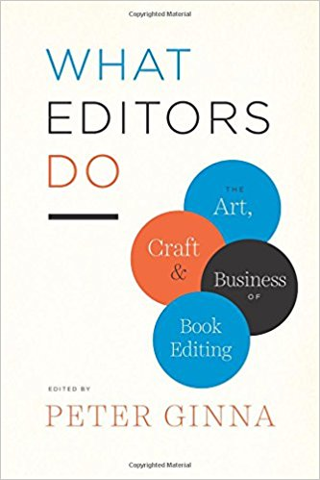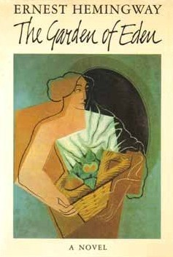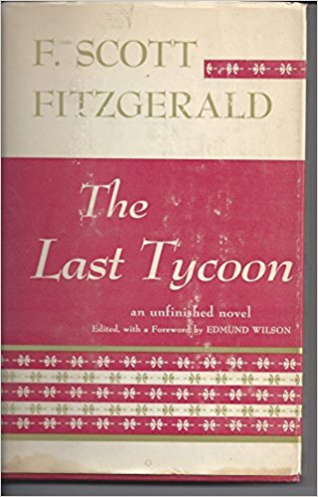

This is ENGL 388: Editorial Process. The primary goal of this course is to immerse students in the field of editorial process. Students will study the field in various ways. The course covers three major areas: 1) Editorial Theory; 2) Textual Editing; and 3) Developmental Editing. A central course text (What Editors Do: The Art, Craft & Business of Book Editing), two case study novels (Hemingway’s The Garden of Eden and Fitzgerald’s The Love of the Last Tycoon, both published posthumously), and various essays will provide students with an expansive yet detailed introduction to the field. Editorial process is the science and art behind the craft of writing for publication, how rough manuscripts become books, and how books become pieces of history. By understanding the forces at work behind the scenes of writing, students will be able to recognize the complex system at work each time they open a new book. Editors, according to Max Perkins, do not create anything…they merely release energy and encourage potential. This course will interrogate the ways in which “editing” services readers, writers, and publishers, and how “editing” means more than correcting grammar and spelling. Several course projects will illuminate the complexities (and possibilities) inherent in editing. Many of the skills needed to be successful in the course translate well into academic and non-academic fields of employment.

Required Course Texts:
- What Editors Do: The Art, Craft & Business of Book Editing. Ed. Peter Ginna. U of Chicago P, 2017. ISBN-13: 9780226299926
- Fitzgerald, F. Scott. The Love of the Last Tycoon. Ed. Matthew J. Bruccoli. Scribner’s, 2003. ISBN-13: 9780020199854
- Hemingway, Ernest. The Garden of Eden. Scribner’s 1986. ISBN-13: 9780684804521
- Course Packet (available for download on D2L)

Rental Text:
The Chicago Manual of Style. 16th Ed. U of Chicago P, 2010.

Assignments:
Editorial Theory Responses 10% (5 at 2% each)
Textual Edition 15%
Editorial Notes 10% (2 at 5% each)
Copy-editing Workbook 15%
Final Reflection Essay (3-5pp.) 10%
Editorial Research Essay (6-8pp.) 20%
Participation 20%

Grading Scale:
A 100-93% B+ 89-87% C+ 79-77% D+ 69-67%
A- 92-90% B 86-83% C 76-73% D 66-65%
B- 82-80% C- 72-70% F 64-0%
Class Policies:
- Discussion Etiquette: On day one we will establish our discussion ground rules as a class. Some things to consider:
  - Our readings will bring up controversial subject matter. As college students and newly minted members of the academy, I expect you to hold yourself with professionalism, good humor, and respect. Degrading others’ opinions, stances, or remarks for any reason at any time will not be tolerated.
  - I want you to disagree with each other. I want you to disagree with me. But disagreement does not mean denigrating, teasing, or hurting one another. Let’s be adults.
  - I want your voice to be heard, and to some that means speaking with me outside of class rather than in class discussions. I am always available for a good chat. Communicate!
- Attendance: ATTENDANCE IS MANDATORY. It is extremely difficult for me to do my job if you are not here. Not only will I be unable to give insight and experience to the class, but your classmates will not be able to help you develop ideas and techniques. I allow three unexcused absences throughout the semester. This is NOT negotiable. If you do not attend my course you will not pass. Period. If you are on an athletic team, you are required to show me documentation from your coach of the days you will be absent. Athletes who miss class because of away games are required to turn their work in prior to leaving for their event.
- Preparing for Class: At the end of each class period I will assign either a reading from the text or a short writing assignment (or both). You are expected to read the assigned texts carefully and thoroughly. DO NOT come to class if you haven’t read the text. You will only hinder the discussion.
- Late Work: All homework is to be turned in ON TIME. No late work will be accepted. Again, NO LATE WORK WILL BE ACCEPTED. NOTE: You must turn in all assignments to pass the class. Failure to turn in any assignment as scheduled will result in an ‘F’ for the class. Late papers will not be accepted.
- Tardiness: I expect you to be on time to class. I begin and end class promptly. I will NEVER keep you over class time. Excessive tardiness will result in absences, and since we only have fifty minutes a day together, we need to stay on course. Be on time.
- Plagiarism: Use of the intellectual property of others without attributing it to them is considered a serious academic offense. Cheating or plagiarism will result in a failing grade for the work or for the entire course. If you think you might be plagiarizing, you probably are. Don’t be the person who cheats. If you are having problems come talk to me about what we can do to help you avoid the cardinal sin of writing. For more detailed information regarding Academic Misconduct please consult: http://www.uwsp.edu/dos/Pages/Academic-Misconduct.aspx.
- Electronic Devices/Video: Electronic devices are distracting and their use while others are speaking is impolite; unless you are asked to use them for a class activity, turn off your cell phones, laptops, Ipads, etc., and put them away. Laptops are not allowed unless we are workshopping, and you must have an Accommodations Request requiring use for a disability. Take notes with pencil and paper. I like pencils, and I like paper. To respect the privacy of those in the class, students may not make audio, video, or photographic recordings of lectures or other class activities without written permission from the instructor. Anyone violating this policy will be asked to turn off the device being used. Refusal to comply with the policy will result in the student being asked to leave the classroom, and possibly being reported to the Dean of Students.
- Accommodations: If you require special accommodations for any reason please let me know. I will do my best to facilitate and arrange the proper accommodation.
- Emails: Email is both a blessing and a curse. Please respect the fact that I am teaching several classes per semester, which means that I will do my very best to respond to your emails within 24 hours during the week (48 hours over the weekend). However, I will not recap entire class periods for you via email (stop by my office instead for some coffee and a chat), nor will I repeat information available on this syllabus or in a class handout (consult course materials before shooting off that email about essay page count). Also, I firmly believe in correspondence etiquette. Email may be informal, but I expect your messages to be polite and respectful. Include a salutation (Dear Dr. Tangedal, Hello Professor Tangedal) and conclusion (sincerely, best, thanks,). Be a pro. If your tone becomes an issue, we will have a talk.
- Office Hours: I hold office hours for your benefit. Come see me any time.

Course Schedule:
Part I. Understanding Editing
1/23 – Introduction to the Class; what is editing?
1/25 – “Introduction”; “The Book’s Journey”, Nancy S. Miller (WED)

1/30 – “What’s Love got to Do with It?: The Author-Editor Relationship”, Betsy Lerner (WED)
2/1 – “Open Heart Surgery, or Just a Nip and Tuck?: Developmental Editing”, Scott Norton (WED)

2/6 – “Toward Accuracy, Clarity, and Consistency: What Copyeditors Do”, Carol Fisher Saller (WED) *Introduce semester-long copy-editing workbook project
2/8 – “The Scholarly Editor as Biographer”, James L.W. West III (P)

Part II. Editorial Theory & Textual Editing
2/13 – “The Printed Book and its Parts”, R.B. McKerrow (P) *Select story/poem for Textual Edition assignment
2/15 – “The Rationale of Copy-Text”, W.W. Greg (P)

2/20 – “The New Look in Editing”, Fredson Bowers (P)
2/22 – “The Editorial Problem of Final Authorial Intention”, G. Thomas Tanselle (P)

2/27 – “The Authority of the Editor and His Formula”, Herschel Parker (P)
3/1 – “The Socialization of Texts”, Jerome McGann (P)

3/6 – “Document and Text: The ‘Life’ of the Literary Work and the Capacities of Editing”, Paul Eggert (P)
3/8 – “Fair Copy, Authorial Intention, and Versioning”, James L.W. West III (P)
3/13 – Editorial Theory Responses Due; Edition Workshop
3/15 – Edition Workshop

Part III. Developmental Editing

3/20 – Textual Edition Due; Query Letters, Synopses, Chapter Outlines: Quality vs. Quantity
*3/22 – “The Flip Side of the Pizza: The Editor as Manager”, Michael Pietsch (WED)

SPRING BREAK

The Love of the Last Tycoon: A Western, F. Scott Fitzgerald

4/3 – The Love of the Last Tycoon, Fitzgerald (1–52)
4/5 – The Love of the Last Tycoon, Fitzgerald (52–129)

4/10 – “Preface”, Matthew J. Bruccoli from The Love of the Last Tycoon
4/12 – The Love of the Last Tycoon, Fitzgerald (“Selected Working Notes”)

The Garden of Eden, Ernest Hemingway

4/17 – Editorial Notes #1 Due; The Garden of Eden, Hemingway (Chs. 1-7)
4/19 – The Garden of Eden, Hemingway (Chs. 8-15)

*4/24 – The Garden of Eden, Hemingway (Chs. 16-23)
4/26 – The Garden of Eden, Hemingway (Chs. 24-30)

5/1 – “Who is the Destructive Type? Re-Reading Literary Jealousy and Destruction in The Garden of Eden”, Carl Eby (P)
5/3 – Editorial Notes #2 Due; “Listening to the Music: Editing Literary Fiction”, Erika Goldman (WED)

5/8 – “This Pencil for Hire: Making a Career as a Freelance Editor”, Katharine O’Moore-Klopf (WED)
5/10 – Copy-Editing Workbook Due; Reflection Due

5/17 – (Thursday) Finals Week Meeting Time (2:45p); Editorial Research Essay Due

